SET OPERATOR INTERSECT -- needs moving to my data

**T**he Oracle INTERSECT operator to is used to compare two queries and returns rows that are output by both.

INTERSECT operator

The Oracle INTERSECT operator compares the result of two [queries](https://www.oracletutorial.com/oracle-basics/oracle-select/) and returns the [distinct](https://www.oracletutorial.com/oracle-basics/oracle-select-distinct/) rows that are output by both queries.

The following statement shows the syntax of the INTERSECT operator:

SELECT list of columns

FROM table1

INTERSECT

SELECT list of columns

FROM table2;

Code language: SQL (Structured Query Language) (sql)

Similar to the [UNION](https://www.oracletutorial.com/oracle-basics/oracle-union/) operator, you must follow these rules when using the INTERSECT operator:

* The number and the order of columns must be the same in the two queries.
* The [data type](https://www.oracletutorial.com/oracle-basics/oracle-data-types/) of the corresponding columns must be in the same data type group such as [numeric](https://www.oracletutorial.com/oracle-basics/oracle-number-data-type/) or character.

Oracle INTERSECT illustration

Suppose we have two queries that return the T1 and T2 result set.

* T1 result set includes 1, 2, 3.
* T2 result set includes 2, 3, 4.

The intersect of T1 and T2 result returns 2 and 3. Because these are distinct values that are output by both queries.

The following picture illustrates the intersection of T1 and T2:

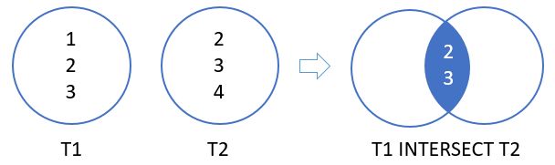

The illustration showed that the INTERSECT returns the intersection of two circles (or sets).

Oracle INTERSECT example

See the following contacts and employees tables in the [sample database](https://www.oracletutorial.com/getting-started/oracle-sample-database/).

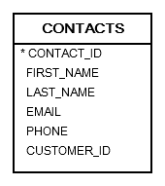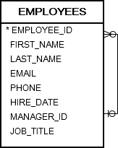

The following statement uses the INTERSECT operator to get the last names used by people in both contacts and employees tables:

SELECT last_name

FROM contacts

INTERSECT

SELECT last_name

FROM employees

ORDER BY last_name;

Code language: SQL (Structured Query Language) (sql)

Note that we placed the [ORDER BY](https://www.oracletutorial.com/oracle-basics/oracle-order-by/) clause at the last queries to sort the result set returned by the INTERSECT operator.

In this tutorial, you have learned how to use the Oracle INTERSECT operator to compare two queries and returns the distinct rows that are output by both queries.